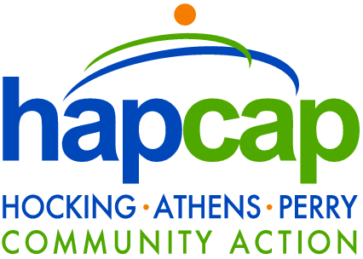

Request for Proposals
Hocking Athens Perry Community Action
Is seeking
On Call After Hours Maintenance Response Services

Date: Friday September 1, 2023

Hocking Athens Perry Community Action is seeking proposals from interested service providers to serve as an after-hours on call emergency maintenance response service provider for Creekside Apartments in Chauncey, Ohio, a 32-unit apartment complex. Contractor will be responsible for responding to emergency maintenance calls from property manager from 4 PM – 8 AM Monday - Friday, and 24 hours per day on all weekends and all holidays. Recent extensive mechanical system replacements occurred at Creekside Apartments in late 2019 / early 2020 consisting of new HVAC systems including gas-fired furnaces, indoor cooling coil and outdoor condensing units as well as new hot water heaters in all apartments. Examples of maintenance emergencies include the following:

- Gas leak / smell
- No heat in winter if temperatures are below 55 degrees.
- No air conditioning in the summer if temperatures are above 85 degrees.
- Uncontrollable water.
- Structural Issues
- Fire
- First floor entry door or window broken and unable to secure unit.
- Toilet blockage if only one commode in the unit.
- Other problems at Management’s discretion if not immediately attended to that could be detrimental to the health and safety or physical damage to property.
Service provider will be expected to be reachable during the above referenced hours of operation and must be able to be on site at 104-109 Lexington Avenue Chauncey, Ohio 45719 within 30-60 minutes or an amount of time that is feasibly reasonable depending on the nature of the maintenance emergency. Service provider will be required to enter into annual contract that stipulates that service provider must:

- Obtain and verify that provider maintains General Liability Coverage and will identify Hocking Athens Perry Community Action as a Certificate Holder.
- Be responsive and reachable during the above described times.
- Hold Hocking Athens Perry Community Action harmless.
- Perform services professionally and with integrity and communicate effectively with property managers.
- Be responsible for maintaining a safe work environment for themselves and residents and nearby neighbors at all times.

To respond to this proposal please include the following:

- A brief narrative of similar professional experience and any related qualification documents.
- Proposed fees and fee structure for responding to calls and hourly rate / fee for service.
- Confirmation that service can begin on October 1, 2023.
Questions can be addressed by contacting Glen Crippen at Hocking Athens Perry Community Action, 3 Cardaras Drive Glouster Ohio 45732 at 740-767-4500 or emailing glen.crippen@hapcap.org.

For full consideration, interested responders must submit proposals by mail to: Director HSG & CD, HAPCAP PO Box 220 Glouster, Ohio 45732 or by emailing glen.crippen@hapcap.org by September 19, 2023 at 4 PM.

